UN Human Rights Council Extends Eritrea Monitoring Mandate Despite Dictator Isaias Afewerqi Objections
UN Human Rights Council Renews Eritrea Rights Watch Mandate Amid Continued Human Rights Concerns
Geneva, July 7, 2026 — The United Nations Human Rights Council has voted to extend the mandate of the Special Rapporteur on the human rights situation in Eritrea for another year, reaffirming international concern over the country's human rights record despite strong objections from the Eritrean government.
The decision ensures that the UN's independent human rights expert will continue monitoring, documenting, and reporting on alleged human rights violations in Eritrea. The mandate also requires regular reports to both the Human Rights Council and the UN General Assembly. Human rights organizations had urged member states to support the renewal, arguing that meaningful progress on fundamental rights has yet to materialize.
According to recent reports presented to the Council, concerns remain over indefinite national service, arbitrary detention, enforced disappearances, restrictions on freedom of expression, freedom of religion, and the lack of an independent judiciary. Rights advocates have also raised concerns about alleged transnational repression targeting members of the Eritrean diaspora.
The Eritrean government has consistently rejected the findings of the Special Rapporteur, describing the mandate as politically motivated and arguing that it unfairly singles out the country. Eritrean officials have repeatedly called for the monitoring mechanism to be discontinued, maintaining that the reports rely on biased and unverified information.
Supporters of the renewed mandate, including numerous international human rights organizations, argue that continued independent scrutiny remains necessary because there has been insufficient improvement in the country's human rights situation. They contend that maintaining international oversight is essential to promoting accountability and encouraging reforms.
The renewal signals that a majority of Council members believe international monitoring of Eritrea should continue until substantial and verifiable progress is made. The Special Rapporteur is expected to continue engaging with the international community, document developments, and present updated findings during future UN sessions.
The vote reflects the Human Rights Council's ongoing commitment to monitoring countries where serious human rights concerns persist, while also highlighting the continuing disagreement between Eritrea and many UN member states over the country's human rights record.

How Countries Voted
The 47-member UN Human Rights Council adopted the resolution by 23 votes in favour, 6 against, and 17 abstentions, extending the mandate of the Special Rapporteur on the situation of human rights in Eritrea for another year.
✅ Voted YES (23 or 24)  - Albania  - Bolivia (Plurinational State of)  - Brazil  - Bulgaria  - Chile  - Colombia  - Cyprus  - Czechia  - Dominican Republic  - Estonia  - Ethiopia  - France  - Iceland  - Italy  - Japan  - Marshall Islands  - Mexico  - Netherlands (Kingdom of the Netherlands)  - North Macedonia  - Republic of Korea  - Slovenia  - Spain  - Switzerland  - United Kingdom of Great Britain and Northern Ireland | ❌ Voted NO (6)  - Burundi  - China  - Cuba  - Egypt  - India  - Pakistan  Result: 23 YES –  17 ABST-AIN –  6 NO | ⚪ Abstained (17)  1. Angola  2. Bangladesh  3. Côte d'Ivoire  4. Democratic Republic of the Congo  5. Gambia  6. Ghana  7. Indonesia  8. Iraq  9. Kenya  10. Kuwait  11. Malawi  12. Mauritius  13. Morocco  14. Qatar  15. South Africa  16. Thailand  17. Viet Nam  Risultato/ሪሱልታቶ/ፍሬ/:  23 እወ-SÌ –  17 ዕጉታት-ASTENUTI –  6 አይኮነን/NO

.......
Tweet
For 12 years, the international community has challenged Isaias Afwerki's regime over indefinite national service, arbitrary detention, enforced disappearances, and the suppression of free expression.
Yet Isaias cannot abandon these abuses—they are the pillars of his rule.
Draconian repression has no place in the 21st century. But a dictator who governs through fear while claiming to defend world order seems determined to export his model beyond Eritrea—to Ethiopia, and perhaps even Indonesia. 08.07.2026

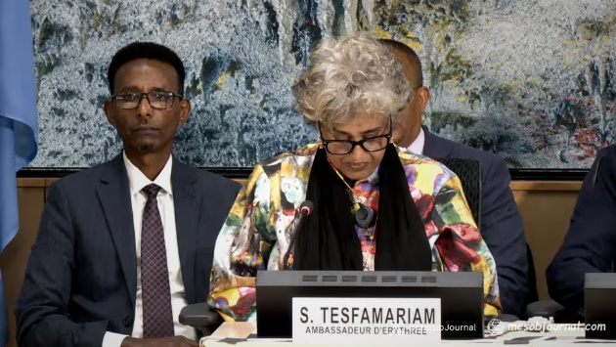 Eritrea Rejects UNHRC Report, Says Rights Mandate Has Lost Credibility
Vocabulary building:
1. monitoring ⧫ ምዕዝዛብ
2. documenting ⧫ ምዝክካር
3. reporting ⧫ ምንጋር
4. alleged ⧫ ቅድምሕሱብ, ሕሱብ, እሙን
5. human rights violations in Eritrea ⧫ ሰበአዊ ቅኑዓት ፍርሰት/ግሕሳን/ቭዮላዝዮነ አብ አሪትራ ⧫ violazioni dei diritti umani in Eritrea.
6. indefinite national service ⧫ ዘይውስሱን ሀገራዊ አግልግሎት
7. arbitrary detention, ⧫ ኣርቢትራርያ ደተንዝዮነ/ ዘይሕግጋዊ እስረት ⧫ detenzione arbitraria,
8. enforced disappearances ⧫ ሕይዩል (ሐይየለ) ህልልምታታት (ህለምበለ) ⧫ sparizioni forzate,
9. restrictions on freedom of expression, ⧫ ረስትሪዝዮኒ/ውስሳኔ ናብ እታ ሓርንነት/ነጻንነት/ሊበርታ ናይ አስፕረስስዮነ ⧫ restrizioni alla libertà di espressione,
10. the lack of an independent judiciary ⧫ እታ ሰአን ናይ ሐንቲ ሓራ/ነጻ ጁዲሽያሪ/ፈራዶ ብእክኩብ ⧫ la mancanza di una magistratura indipendente

Eyob Ghebreziabhier
Sewwit.Org
08.07.2026

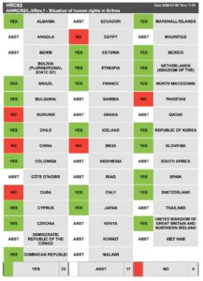
Albania

